OLVM: Create FC Shared Data Domain
https://eclipsys.ca/olvm-create-fc-shared-data-domain/
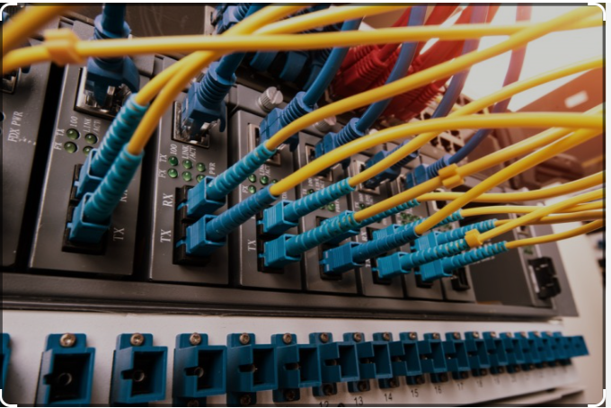

Introduction
Nowadays all the business markets are highly competitive and organizations want to take competitive advantages over others. When business is highly critical databases and application servers need to be up and running 24X7. Virtualization is the technology that helps to maximize the IT infrastructure cost. High availability of VM can be achieved easily from virtualization clustering. Also, Virtualization technology will ease the cloud migration journey.
Virtualization can be deployed in two ways
- Converged Architecture
- Hyper-converged Architecture
Below mentioned links are useful for getting a clear understanding of both types of deployment types.
Converged Deployment : https://www.bmc.com/blogs/converged-infrastructure-vs-hyper-converged-infrastructure/#:~:text=In%20a%20non%2Dconverged%20architecture,Network%2Dattached%20storage%20(NAS)
Hyperconverged:https://www.redhat.com/en/topics/hyperconverged-infrastructure/what-is-hyperconverged-infrastructure.

What is Converged Architecture?
In a non-converged architecture, physical servers operate a virtualization hypervisor that manages each of the virtual machines (VMs) that have been created on the server. For data storage, there are typically three options:
- A Storage-area Network (SAN)
- Direct-attached Storage (DAS)
- Network-attached Storage (NAS)
With converged architecture, storage is attached directly to the physical server. Regular converged architecture can be just as fast (if not faster) than hyper-converged alternatives. In this setup, flash storage is almost always used. (The need for expensive SAN and NAS, in particular, is eliminated.)

What is Hyper-converged Architecture?
Hyperconvergence is an approach to IT infrastructure that consolidates computing, storage, and networking resources into a unified system. A hyper-converged infrastructure (HCI) consists of compute resources (virtual machines) managed with a hypervisor, software-defined storage, and software-defined networking. Hyperconvergence of virtualized resources allows you to manage your resources from a single, unified interface.
With software-defined computing and storage integrated together, you can reduce data center complexity and footprint and support more modern workloads with flexible architectures on industry-standard hardware.
There are a few prerequisites you need to understand before creating a cluster.
- Are you going with converged or hyper-converged architecture?
- How many nodes do you need to cluster which helps with fencing and shared storage?
- What is the virtualization management network bandwidth?
- What is the shared storage type best suited for the environment?
For optimal virtualization architecture, we need at least 3 nodes. Having 3 nodes will handle the fencing more efficiently than 2 nodes.
All depend on the capex cost, you can start with 2 nodes and plan to move 3 nodes within 2 years or so. There is no restriction that you cannot create an OLVM cluster with 2 nodes, but some of the fencing features will not work as expected.
Note: Make sure not to implement glusterfs with 2 nodes. Glusterfs hyper-converged architecture storage you need to have 3 nodes.
In this article, I will cover how to implement a shared fiber domain between two nodes.
As per Figure 1: Fiber LUN should be mapped to both the KVM nodes. In OLVM shared cluster SPM (Storage Pool Manager) Role will handle this shared storage mounting in both nodes.
Note: Make sure to map the same Fiber LUN to both nodes
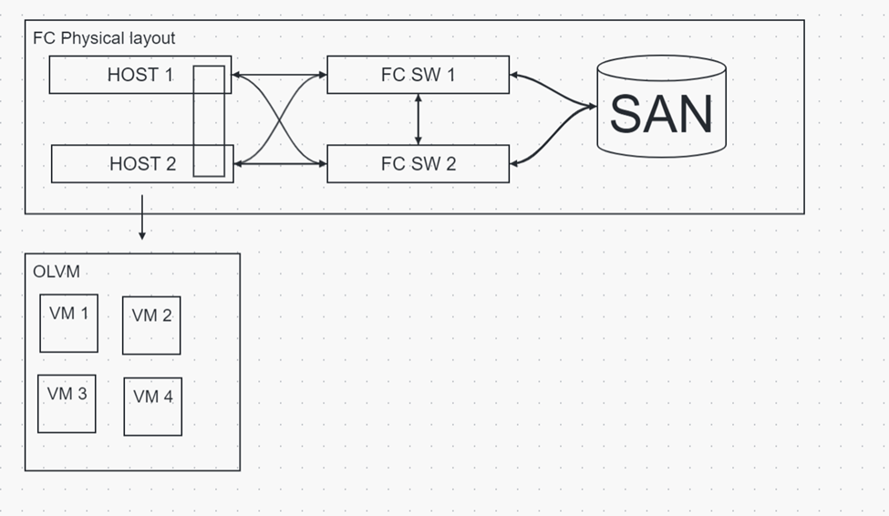
Figure 1: How to map the Fiber storage domain to both nodes

Mapping Fiber LUN to node01
[root@KVM01 ~]# lsblk | grep 3624a93701561d6718da94a200001104c
└─3624a93701561d6718da94a200001104c 252:2 0 200G 0 mpath
└─3624a93701561d6718da94a200001104c 252:2 0 200G 0 mpath
└─3624a93701561d6718da94a200001104c 252:2 0 200G 0 mpath
└─3624a93701561d6718da94a200001104c 252:2 0 200G 0 mpath
[root@KVM120 ~]#
Mapping Fiber LUN to node02
[root@KVM02 ~]# lsblk | grep 3624a93701561d6718da94a200001104c
└─3624a93701561d6718da94a200001104c 252:2 0 200G 0 mpath
└─3624a93701561d6718da94a200001104c 252:2 0 200G 0 mpath
└─3624a93701561d6718da94a200001104c 252:2 0 200G 0 mpath
└─3624a93701561d6718da94a200001104c 252:2 0 200G 0 mpath
[root@KVM121 ~]#

Adding FC Storage from OLVM
Figure 2: Illustrates how to create a fiber channel data domain, Always double-check the LUN ID before selecting the disk. This will take 10min to create the lvm2 and the file structure.
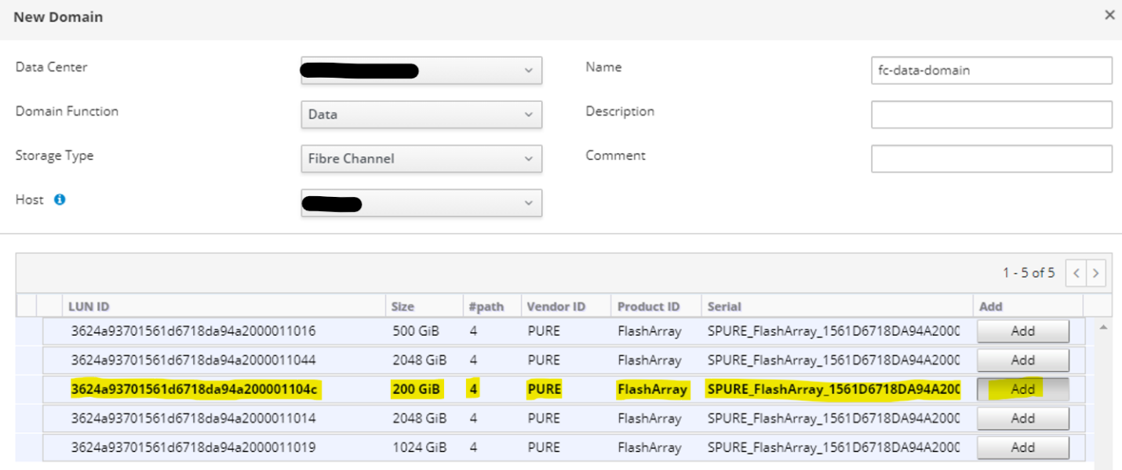
Figure 2: Add Fiber LUN as an FC-Data-Domain

If this is created successfully, all 3 tasks will be completed with a green color taskbar.
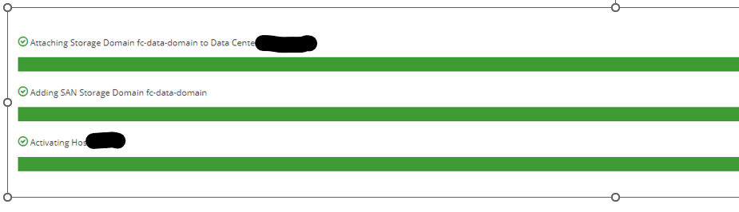
Figure 3: OLVM Task Detail Tab

Once you successfully created the fc domain, the status will be displayed in green color in the storage section.
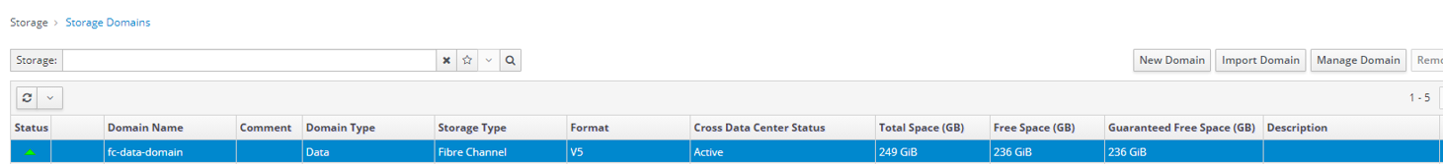

Conclusion
In summary, For two nodes not giving you the expected fencing results. When designing the OLVM architecture with gluster storage optimal results can be archived via 3 node architectures.
For two-node architectures, we can achieve OLVM environmental stability by implementing fiber channel storage domains. if you are still planning to have gluster storage, KVM must consist of 10G network cards. Also, we need to implement an arbitrator to avoid split brain.
Moving to fiber storage will completely eliminate the network traffic from the management network. OLVM SPM (Storage Pool Manager) will handle the mounting on both nodes. Also, fiber gives you enhanced performance on storage.

